|  |  |
| --- | --- |
| section II - TRANSPORTATION  Contents |  |

200.000 AMBULANCE TRANSPORTATION GENERAL INFORMATION

201.000 Arkansas Medicaid Participation Requirements for Ambulance Transportation Providers

201.100 Ground Ambulance Providers

201.200 Air Ambulance Providers

202.000 Providers in Arkansas and Bordering States

202.100 Routine Services Provider

203.000 Ambulance Providers in States Not Bordering Arkansas

204.000 Physician’s Role in Non-Emergency Ambulance Services

205.000 Records Ambulance Providers Are Required to Keep

210.000 PROGRAM COVERAGE

211.000 Introduction

212.000 Scope

212.100 Subscription Plans for Ambulance Services

213.000 Pick-Up and Delivery Locations

213.100 Reserved

213.200 Exclusions

214.000 Covered Ground Ambulance Services

214.100 Covered Ground Ambulance Triage, Treat, and Transport to Alternative Location/Destination Services

214.110 Scope

214.120 Alternative Location and Alternative Destination

215.000 Covered Air Ambulance Services

216.000 Ambulance Trips with Multiple Medicaid Beneficiaries

230.000 PRIOR AUTHORIZATION

231.000 Ground Ambulance Trips Out-of-State

232.000 Air Ambulance

240.000 REIMBURSEMENT

241.000 Method of Reimbursement

241.010 Fee Schedule

241.100 Air Ambulance

241.200 Emergency Medical Transportation Access Payment

242.000 Rate Appeal Process

250.000 Ambulance BILLING PROCEDURES

251.000 Introduction to Billing

252.000 CMS-1500 Billing Procedures

252.100 Ambulance Procedure Codes

252.110 National Drug Codes (NDC) Billing Protocol

252.200 National Place of Service

252.300 Ambulance Transportation Billing Instructions—Paper Only

252.310 Completion of CMS-1500 Claim Form

252.400 Special Billing Procedures

252.410 Levels of Ambulance Life Support (ALS) and Basic Life Support (BLS)

252.420 Medical Necessity Requirement

|  |  |
| --- | --- |
| 200.000 AMBULANCE TRANSPORTATION GENERAL INFORMATION |  |
| 201.000 Arkansas Medicaid Participation Requirements for Ambulance Transportation Providers |  |
| 201.100 Ground Ambulance Providers | 8-3-20 |

Ground Ambulance Transportation providers must meet the Provider Participation and enrollment requirements contained within Section 140.000 of the Arkansas Medicaid provider manual as well as the following criteria in order to be eligible for participation in the Arkansas Medicaid Program:

A. A current copy of the ambulance license issued by the Arkansas Department of Health (in-state providers) or the applicable licensing authority (out-of-state and bordering state providers) must accompany the provider application and Medicaid contract. Medicaid will accept approved electronic signatures provided the signatures comply with Arkansas Code § 25-31-103 et seq.

B. Ambulance transportation providers who wish to be reimbursed for Advanced Life Support services must submit a current copy of the ambulance license that reflects Paramedic or Advanced Emergency Medical Technician (EMT) licensure from the Arkansas Department of Health (for in-state providers) or the applicable licensing authority (out-of-state providers). Please refer to Section 252.410 for special billing instructions regarding Advanced Life Support.

C. The ambulance company must be enrolled in the Title XVIII (Medicare) Program.

|  |  |
| --- | --- |
| 201.200 Air Ambulance Providers | 7-1-12 |

Air Ambulance Transportation providers must meet the Provider Participation and enrollment requirements contained within Section 140.000 of this manual as well as the following criteria in order to be eligible for participation in the Arkansas Medicaid Program:

A. The ambulance company must be in enrolled in the Title XVIII (Medicare) Program. Medicaid will accept approved electronic signatures provided the signatures comply with Arkansas Code § 25-31-103 et seq.

B. A current copy of the ambulance license issued by the Arkansas Department of Health (in-state providers) or the applicable licensing authority (out-of-state and bordering state providers) must accompany the provider application and Medicaid contract.

|  |  |
| --- | --- |
| 202.000 Providers in Arkansas and Bordering States | 10-13-03 |

Ambulance providers in Arkansas and the six bordering states (Louisiana, Mississippi, Missouri, Oklahoma, Tennessee and Texas) will be enrolled as routine services providers.

|  |  |
| --- | --- |
| 202.100 Routine Services Provider | 10-13-03 |

A. Providers in Arkansas and bordering states must enroll in the program as a Routine Services Provider.

B. Reimbursement will be available for all ambulance transportation services covered in the Arkansas Medicaid Program.

C. Claims must be filed according to the specifications in this manual. This includes assignment of HCPCS codes for all services rendered.

|  |  |
| --- | --- |
| 203.000 Ambulance Providers in States Not Bordering Arkansas | 3-1-11 |

A. Providers in states not bordering Arkansas may enroll in the Arkansas Medicaid program as limited services providers only after they have provided services to an Arkansas Medicaid eligible beneficiary and have a claim or claims to file with Arkansas Medicaid.

To enroll, a non-bordering state provider must download an Arkansas Medicaid application and contract from the Arkansas Medicaid website and submit the application, contract and claim to Arkansas Medicaid Provider Enrollment. A provider number will be assigned upon approval of the provider application and the Medicaid contract. [View or print Provider Enrollment Unit Contact information.](https://humanservices.arkansas.gov/wp-content/uploads/ProviderEnrol.docx) [View or print the provider enrollment and contract package (Application Packet).](https://humanservices.arkansas.gov/wp-content/uploads/ApplicationPacket.pdf)

B. Limited services providers remain enrolled for one year.

1. If a limited services provider provides services to another Arkansas Medicaid beneficiary during the year of enrollment and bills Medicaid, the enrollment may continue for one year past the most recent claim’s last date of service, if the enrollment file is kept current.

2. During the enrollment period, the provider may file any subsequent claims directly to the Medicaid fiscal agent.

3. Limited services providers are strongly encouraged to file subsequent claims through the Arkansas Medicaid website because the front-end processing of web-based claims ensures prompt adjudication and facilitates reimbursement.

|  |  |
| --- | --- |
| 204.000 Physician’s Role in Non-Emergency Ambulance Services | 8-3-20 |

Physician certification statements (PCS) are required for patients who are under the direct care of a physician and are required for:

A. Scheduled non-emergency ambulance transports

B. Unscheduled non-emergency ambulance transports

Ambulance suppliers must obtain certification from the patient’s attending physician verifying the medical necessity of ambulance transportation in certain circumstances. The physician certification must be accurate and timely as it enables billing Medicaid to receive payment.

The attending physician is responsible for supervising the medical care of the patient by:

A. Reviewing the patient’s program of care;

B. Ordering medications;

C. Monitoring changes in the patient’s medical status; and,

D. Signing and dating all orders.

NOTE: The signed PCS does not, by itself, demonstrate the transport was medically necessary and does not absolve the ambulance provider from meeting all other coverage criteria.

**Scheduled Repetitive Transports**

Definition of Repetitive Ambulance Service:

A repetitive ambulance service is defined as medically necessary ambulance transportation that is furnished three (3) or more times during a 10-day period, or at least once per week for at least three (3) weeks. For example, members receiving dialysis or cancer treatment may need repetitive ambulance services.

PCS requirements for non-emergency scheduled repetitive ambulance transportation include the following:

A. The PCS for repetitive transports must be signed and dated by the attending physician before furnishing the services to the patient.

B. The PCS must be dated no earlier than sixty (60) days in advance of the transport for those patients who require repetitive ambulance services and whose transportation is scheduled in advance.

C. The PCS may include the expected length of time ambulance transport would be required not to exceed sixty (60) days.

**Non-Repetitive Transports**

A. PCS requirements for non-emergency (whether scheduled, or not) on a non-repetitive basis ambulance transportation include the following rules:

1. The PCS must be obtained from the attending physician within forty-eight (48) hours after the transport

2. If the ambulance provider is unable to obtain the PCS from the attending physician within forty-eight (48) hours of transport, the provider may submit a claim within twenty-one (21) days if a certification has been obtained from one (1) of the following who is knowledgeable about the patient’s condition and who is employed by either the attending physician or the facility to which the patient is admitted:

a. Physician Assistant;

b. Nurse Practitioner;

c. Clinical Nurse Specialist;

d. Registered Nurse; or,

e. Discharge Planner.

B. If the ambulance provider is unable to obtain the written order within the 48-hour limit, the supplier may submit the claim after twenty-one (21) days if there is documentation of attempts to obtain the order and certification. The provider may send a letter via U.S. Postal certified mail using the return and/or proof of mailing or other similar service demonstrating delivery of the letter as evidence of the attempt to obtain the PCS.

**Non-emergency ambulance service claims are subject to review and recoupment by DHS or its designated representatives.**

|  |  |
| --- | --- |
| 205.000 Records Ambulance Providers Are Required to Keep | 8-3-20 |

A. Ambulance providers are required to keep the following records and, upon request, to immediately furnish the records to authorized representatives of the Arkansas Division of Medical Services and the State Medicaid Fraud Control Unit and to representatives of the Department of Human Services:

1. The beneficiary’s diagnosis, ICD code, if known, or the conditions or symptoms requiring non-emergency ambulance service. (Diagnosis is not required for emergency ground ambulance service.)

2. Copy of the Physician Certification Statement (PCS) for non-emergency ambulance service to include the ICD diagnosis code, if known, or the conditions or symptoms establishing medical necessity.

3. Documentation required by Medicare for ambulance services provided to dual-eligible beneficiaries.

4. Number of miles traveled – Mileage at transport origin and mileage at transport destination, while loaded, must be documented. Mileage is paid only for that part of the trip the patient is a passenger in the ambulance. The loaded miles must be recorded on the Patient Care Report (PCR). The provider is still responsible for ensuring trip mileage is **measured and reported** accurately, even in cases where the ambulance personnel fail to reset the trip odometer at the beginning of the trip. Detailed explanation of what occurred must be documented. Acceptable tools used to measure mileage include:

a. Odometer readings (both beginning and ending mileage must be documented);

b. Global Positioning Systems (GPS) (GPS printout must be included in documentation); and,

c. Map mileage documented by using an electronic mapping system (such as Google Maps or MapQuest)

The provider is responsible for ensuring any tools used to measure trip mileage are in working order. Ambulance providers are required to use the shortest route in time between point “A” to “B”. If the shortest route cannot be used, the reason why must be documented.

5. The Patient Care Report (PCR) is documentation used in both non-emergency and emergency transports and should contain at a minimum:

a. Origin of the call (i.e., 911, hospital, nursing home, private residence);

b. Origin of transport or pick-up (on occasion the origin of the call and the pick-up location are different);

c. Date and times inclusive of time call received, unit in route to scene, arrival on scene, en route to destination, arrival at destination;

d. The Arkansas Department of Health (ADH) vehicle permit number or the unit call sign of the responding unit/ambulance (if licensed in Arkansas);

e. The patient’s name;

f. Certification/licensure of all crew members responding, unit and the level of ambulance service provided; and,

g. A complete subjective and objective assessment of patient being transported, monitoring of patient’s condition, and supplies used in transport.

B. All required records must be kept for a period of five (5) years from the ending date of service; or until all audit questions, appeal hearings, investigations, or court cases are resolved, whichever period is longer.

C. Furnishing medical records on request to authorized individuals and agencies listed above in subpart A is a contractual obligation of providers enrolled in the Medicaid Program. Failure to furnish medical records upon request may result in the imposition of sanctions.

D. The provider must contemporaneously establish and maintain records that completely and accurately explain all assessments and aspects of care, including the response, interview, physical exam, any diagnostic procedures performed, any non-invasive or invasive procedures performed, diagnoses, supplies used, and any other activities performed in connection with any Medicaid beneficiary.

E. At the time of an audit by the Office of Medicaid Inspector General, all documentation must be available at the provider’s place of business during normal business hours. There will be no more than thirty (30) days allowed after the date of any recoupment notice in which additional documentation will be accepted.

|  |  |
| --- | --- |
| 210.000 PROGRAM COVERAGE |  |
| 211.000 Introduction | 9-1-06 |

The Medical Assistance (Medicaid) Program is designed to assist Medicaid beneficiaries in obtaining medical care within the guidelines specified in Section I of this manual. Reimbursement may be made for ambulance services within the Medicaid Program’s limitations. Ambulance services must be certified as medically necessary by a physician.

|  |  |
| --- | --- |
| 212.000 Scope | 7-1-12 |

Emergency ambulance services may be covered only when provided by an ambulance company that is licensed and is an enrolled provider in the Arkansas Medicaid Program. Emergency ambulance services may be covered only when an emergency exists for the transported individual. (See the Glossary—Section IV of this manual—for a definition of “emergency services.”)

Ground ambulance services must be provided by a licensed ambulance service, even if the trip is a routine or non-emergency transfer.

Air ambulance services are covered for eligible Medicaid beneficiaries on an emergency basis or as deemed medically necessary by a physician.

When emergency ambulance services are provided as described above, and the beneficiary is transported to the hospital, the Arkansas Medicaid Program will cover the ambulance transportation only when the beneficiary is admitted to the hospital or when the patient’s condition is an emergency. (See the Glossary—Section IV of this manual—for a definition of “emergency services.”)

Emergency ambulance services provided in response to a 911 call are often requested by someone other than a physician. In these situations, the name of the ordering physician is not available. Emergency transport is provided when the absence of immediate attention could place the patient’s health at risk. Signs and symptoms that warrant the emergency transportation must be documented in the Patient Care Report.

Emergency transportation requests originating from an acute care hospital must have a physician certification statement (PCS).

Emergency ambulance service claims are subject to review and recoupment by DHS or its designated representative.

|  |  |
| --- | --- |
| 212.100 Subscription Plans for Ambulance Services | 9-1-08 |

When ambulance subscription plans operate as insurance policies, Medicaid considers them third party resources. Federal regulations define private insurer, in part, to be “any…prepaid plan offering either medical services or full or partial payment…” As long as the membership fee paid by a Medicaid beneficiary is treated by the ambulance subscription plan as an insurance premium and the ambulance company does not then bill Medicaid for ambulance services provided to the Medicaid beneficiary, the ambulance company will not be in violation of Medicaid regulations. If, on the other hand, the ambulance provider collects a membership fee from Medicaid beneficiaries and then bills Medicaid for ambulance services provided to those Medicaid beneficiaries, the provider will be in violation of the Medicaid regulations by soliciting and/or accepting the membership fee.

Any ambulance company that markets a subscription plan must make it very clear in its marketing materials that Medicaid beneficiaries are not required to pay an enrollment fee to the subscription plan or make voluntary contribution to the subscription plan provider in order to avoid charges for medically necessary ambulance transportation.

|  |  |
| --- | --- |
| 213.000 Pick-Up and Delivery Locations | 7-1-12 |

Medicaid will cover ambulance services for Medicaid beneficiaries to and/or from the following locations. Certification of medical necessity by the physician is required for routine scheduled or non-emergency ground ambulance transport:

A. From the location a beneficiary has an accident or becomes ill to a hospital.

B. From the patient’s home or place of residence to a hospital.

C. From a nursing home to a hospital.

D. From a hospital (after receiving emergency outpatient treatment) to a nursing home if the patient meets medical necessity requirements for non-emergency ambulance transport and the physician certification has been obtained.

E. From a hospital (after being discharged from an inpatient stay) to a nursing home when the beneficiary is being admitted to the nursing home.

F. From a hospital to a hospital for inpatient services. However, if a patient is transported from a hospital to receive services on an outpatient basis, the cost of the ambulance is included in the hospital reimbursement amount. The ambulance company may not bill Medicaid or the beneficiary for the service.

G. From the patient’s home or place of residence to a nursing home when the beneficiary is being admitted to the nursing home.

H. From a nursing home (after being discharged) to a patient’s home or place of residence.

I. From a hospital to the patient’s home or place of residence following an inpatient hospital stay.

J. From a nursing home to a nursing home when the original nursing home has been decertified by Medicaid and the transportation is determined necessary by the Office of Long Term Care, Arkansas Division of Medical Services. In these instances, the Arkansas Medicaid Program will contact the Ambulance Transportation provider who is rendering the service to provide special billing instructions.

|  |  |
| --- | --- |
| 213.100 Reserved | 4-30-10 |
| 213.200 Exclusions | 2-1-24 |

Ambulance service to a doctor’s office or clinic is not covered, except as described in Sections 204.000 and 214.100.

|  |  |
| --- | --- |
| 214.000 Covered Ground Ambulance Services | 8-3-20 |

The following services are covered by Medicaid during the trips listed in Sections 213.000 through 213.200:

A. Non-Emergency Pick Up Base Service;

B. Emergency Pick Up Base Service;

C. Mileage Rate - One Way (in addition to basic); and,

D. Disposable Supplies and Drugs as described in Section 252.100.

Mileage must be calculated in accordance with Section 205.000.

|  |  |
| --- | --- |
| 214.100 Covered Ground Ambulance Triage, Treat, and Transport to Alternative Location/Destination Services | 2-1-24 |

Ground ambulance triage, treat, and transport to alternative location/destination services (T3AL) may be covered only when provided by an ambulance company that is licensed and is an enrolled provider in the Arkansas Medicaid Program. An ambulance service may triage and transport a beneficiary to an alternative destination or treat in place if the ambulance service is coordinating the care of the beneficiary through telemedicine with a physician for a medical-based complaint or with a behavioral health specialist for a behavioral-based complaint. Telemedicine rules are described in Section 105.190 and must be followed unless instructions are given within Section II of the prevailing Medicaid manual. The use of audio-only electronic technology is not allowed for T3AL services.

For the purposes of T3AL, a behavioral health specialist is a board-certified psychiatrist or an Independently Licensed Practitioner who can provide counseling services to Medicaid beneficiaries in the Outpatient Behavioral Health program.

|  |  |
| --- | --- |
| 214.110 Scope | 2-1-24 |

An ambulance service may:

A. Treat a beneficiary in alternative location if the ambulance service is coordinating the care of the beneficiary through telemedicine with a physician for a medical-based complaint or with a behavioral health specialist for a behavioral-based complaint; or

B. Triage or triage and transport a beneficiary to an alternative destination if the ambulance service is coordinating the care of the beneficiary through telemedicine with a physician for a medical-based complaint or with a behavioral health specialist for a behavioral-based complaint.

An encounter between an ambulance service and a beneficiary that results in no transport of the enrollee is allowable if the beneficiary declines to be transported against medical advice and the ambulance service is coordinating the care of the beneficiary through telemedicine with a physician for a medical-based complaint.

An encounter between an ambulance service and a beneficiary is billable as follows:

A. The ambulance service may bill either a basic life support (BLS) or advanced life support (ALS) service according to the level of the service provided to the beneficiary, plus mileage. Mileage may be billed for treating in the alternative location (one-way mileage to the location of the beneficiary. Mileage rules set forth in Section 204.000, 205.000, 214.000, and 216.000 will otherwise be followed.

|  |  |
| --- | --- |
| 214.120 Alternative Location and Alternative Destination | 2-1-24 |

Alternative location is the location to which an ambulance is dispatched, and ambulance service treatment is initiated as a result of a 911 call that is documented in the records of the ambulance service.

Alternative destination means a lower-acuity facility that provides medical services, including:

A. A federally qualified health center;

B. An urgent care center;

C. A physician's office or medical clinic, as chosen by the patient;

D. A behavioral or mental healthcare facility

Excluded alternative destinations are facilities that provide a higher-acuity medical service or medical services for routine chronic conditions including:

A. Emergency Room

B. Critical Access Hospital;

C. Rural Emergency Hospital;

D. Dialysis center;

E. Hospital;

F. Private residence;

G. Skilled nursing facility

|  |  |
| --- | --- |
| 215.000 Covered Air Ambulance Services | 2-1-22 |

Please refer to Section 241.100 for reimbursement information. Please refer to Section 252.100 for covered air ambulance services and the payable procedure codes.

|  |  |
| --- | --- |
| 216.000 Ambulance Trips with Multiple Medicaid Beneficiaries | 8-3-20 |

There will be occasions when more than one (1) eligible Medicaid beneficiary is picked up and transported in an ambulance at the same time. When this situation exists, the procedures listed below must be followed:

A. A separate claim must be filed for each eligible Medicaid beneficiary. Each claim must have a physician certification, except in situations when multiple patients are transported as a result of an emergency response. All documentation supporting the medical necessity of transporting multiple patients in an ambulance must be kept for retrospective review.

B. If there is a mileage charge, it must be charged on only one (1) of the eligible beneficiary’s claims.

C. The base service and other procedures that are used and appropriately documented may be charged on each eligible beneficiary’s claim.

NOTE: If an eligible beneficiary and her newborn child are transported at the same time, the above procedures will apply. However, if the newborn has not been certified Medicaid eligible, it will be the responsibility of the parent(s) to apply and meet the eligibility requirements for the newborn to be certified as Medicaid eligible. If the newborn is not certified as Medicaid eligible, the parent(s) will be responsible for the charges incurred by the newborn.

|  |  |
| --- | --- |
| 230.000 PRIOR AUTHORIZATION |  |
| 231.000 Ground Ambulance Trips Out-of-State | 10-13-03 |

Prior authorization must be obtained from the Arkansas Division of Medical Services, Utilization Review Section for ambulance trips to a medical facility outside the State of Arkansas, unless the medical facility is within a 50-mile trade area and is the nearest hospital or nursing home from the point of pick-up. [View or print the Arkansas Division of Medical Services, Utilization Review Section contact information.](https://humanservices.arkansas.gov/wp-content/uploads/DMSUR.docx)

|  |  |
| --- | --- |
| 232.000 Air Ambulance | 10-13-03 |

Prior authorization is not required for any air ambulance services.

**EXAMPLE:** An ambulance trip to a hospital in Dallas, Texas, or St. Louis, Missouri, would require prior authorization. However, an ambulance trip to a hospital in Poplar Bluff, Missouri; Greenville, Mississippi or Poteau, Oklahoma, would not require prior authorization because these and similar locations are considered within a 50-mile trade area. Memphis, Tennessee, and Texarkana, Texas, are considered in-state locations.

|  |  |
| --- | --- |
| 240.000 REIMBURSEMENT |  |
| 241.000 Method of Reimbursement | 8-3-20 |

Ambulance services are reimbursed based on the lesser of the amount billed or the Title XIX (Medicaid) charge allowed.

|  |  |
| --- | --- |
| 241.010 Fee Schedule | 12-1-12 |

Arkansas Medicaid provides fee schedules on the Arkansas Medicaid website. The fee schedule link is located at [https://medicaid.mmis.arkansas.gov/](https://humanservices.arkansas.gov/divisions-shared-services/medical-services/helpful-information-for-providers/fee-schedules/) under the provider manual section. The fees represent the fee-for-service reimbursement methodology.

Fee schedules do not address coverage limitations or special instructions applied by Arkansas Medicaid before final payment is determined.

Procedure codes and/or fee schedules do not guarantee payment, coverage or amount allowed. Information may be changed or updated at any time to correct a discrepancy and/or error. Arkansas Medicaid always reimburses the lesser of the amount billed or the Medicaid maximum.

|  |  |
| --- | --- |
| 241.100 Air Ambulance | 2-1-22 |

Arkansas Medicaid reimburses turboprop, piston propelled and jet aircraft air ambulance services per hour of services (medical services) and per mileage (aircraft operating costs). The hourly rate will only be reimbursed for time while the aircraft is in the air, on the runway for takeoff and landing, boarding and disembarking patient and crew, and taxiing.

Arkansas Medicaid will reimburse ground transport salary and fringe expenses for the aircraft medical crew up to a maximum of $1,000 per total roundtrip flight for air nursing crew and air paramedic crew procedure codes. (See Section 252.100 for procedure codes.) This reimbursement can only be made for medical crew assistance time while:

A. The crew travels to the hospital to pick up the patients;

B. The patient is being transported from the original hospital to the aircraft;

C. The patient is being transported from the aircraft to the receiving hospital and

D. The crew is traveling back to the aircraft after delivering the patient to the receiving hospital.

The ground transport medical crew time is reimbursable whether or not the crew actually accompanies the patient in the ground transport ambulance. The crew may travel in a separate vehicle, if necessary.

Arkansas Medicaid will reimburse air transport ventilator and respiratory therapist services. This service will only be reimbursed, when necessary, for patient care during transportation.

|  |  |
| --- | --- |
| 241.200 Emergency Medical Transportation Access Payment | 6-4-22 |

Qualifying medical transportation providers within the State of Arkansas, except for volunteer ambulance services, ambulance services owned by the state, county, or political subdivision, air ambulance services, specialty hospital-based ambulance services, and ambulance services subject to the state’s assessment on the revenue of hospitals shall be eligible to receive emergency medical transportation access payments. All emergency medical transportation providers that meet this definition will be referred to as Qualified Emergency Medical Transportation (QEMT) providers.

The emergency medical transportation access payment to each QEMT shall be calculated on an annual basis and paid out quarterly. The access payment shall be comprehensive and will be eighty percent (80%) of the difference between Medicaid payments otherwise made to QEMTs for the provision of emergency medical transportation services and the average amount that would have been paid at the equivalent community rate (hereinafter, average commercial rate or ACR). Emergency Medical Transportation Access Payments shall be made on a quarterly basis. [View the Administrative Procedures for the Emergency Medical Transportation Assessment Fee and Access Payment](https://humanservices.arkansas.gov/wp-content/uploads/EmerMedTranspAdminProc.docx).

[View or print form DMS-0600, Initial Medical Transportation Access Payment Revenue Survey](https://humanservices.arkansas.gov/wp-content/uploads/DMS-0600.docx).

[View or print form DMS-0601, Emergency Medicaid Transportation Access Payment Application.](https://humanservices.arkansas.gov/wp-content/uploads/DMS-0601.docx)

|  |  |
| --- | --- |
| 242.000 Rate Appeal Process | 9-1-08 |

A provider may request reconsideration of a Program decision by writing to the Assistant Director, Division of Medical Services. This request must be received within 20 calendar days following the application of policy and/or procedure or the notification of the provider of its rate. Upon receipt of the request for review, the Assistant Director will determine the need for a program/provider conference and will contact the provider to arrange a conference if needed. Regardless of the program decision, the provider will be afforded the opportunity for a conference, if he or she so wishes, for a full explanation of the factors involved and the program decision. Following review of the matter, the Assistant Director will notify the provider of the action to be taken by the Division within 20 calendar days of receipt of the request for review or the date of the program/provider conference.

If the decision of the Assistant Director, Division of Medical Services is unsatisfactory, the provider may then appeal the question to a standing Rate Review Panel established by the Director of the Division of Medical Services which will include one member of the Division of Medical Services, a representative of the provider association and a member of the Department of Human Services (DHS) Management Staff, who will serve as chairman.

The request for review by the Rate Review Panel must be postmarked within 15 calendar days following the notification of the initial decision by the Assistant Director, Division of Medical Services. The Rate Review Panel will meet to consider the question(s) within 15 calendar days after receipt of a request for such appeal. The question(s) will be heard by the panel and a recommendation will be submitted to the Director of the Division of Medical Services.

|  |  |
| --- | --- |
| 250.000 Ambulance BILLING PROCEDURES |  |
| 251.000 Introduction to Billing | 8-3-20 |

Ambulance transportation providers use the CMS-1500 claim format to bill the Arkansas Medicaid Program for services provided to eligible Medicaid beneficiaries. Each claim must contain charges for only one (1) beneficiary. For a date of service where more than one (1) ambulance service was provided, all service runs must be billed on one (1) claim.

Section III of this manual contains information about Provider Electronic Solutions (PES) and other available options.

|  |  |
| --- | --- |
| 252.000 CMS-1500 Billing Procedures |  |

|  |  |
| --- | --- |
| 252.100 Ambulance Procedure Codes | 1-1-23 |

The covered ambulance procedure codes are listed below.

[View or print the procedure codes for Transportation (Ambulance) services.](https://humanservices.arkansas.gov/wp-content/uploads/TRANSP_ProcCodes.xlsx)

Drug procedure codes require National Drug Codes (NDC) billing protocol. See Section 252.110 below.

*Procedure code can be billed only in conjunction with procedure code **(please keep all documentation supporting the medical necessity of all codes billed for retrospective review of claims).**

Arkansas Medicaid follows the billing protocol per the Federal Deficit Reduction Act of 2005 for drugs.

A. Multiple units may be billed when applicable. Take-home drugs are not covered. Drugs loaded into an infusion pump are not classified as “take-home drugs.” Refer to payable CPT code ranges.

B. When submitting Arkansas Medicaid drug claims, drug units should be reported in multiples of the dosage included in the HCPCS procedure code description. If the dosage given is not a multiple of the number provided in the HCPCS code description the provider shall round up to the nearest whole number in order to express the HCPCS description number as a multiple.

1. **Single-Use Vials:** If the provider must discard the remainder of a **single-use vial** or other package after administering the prescribed dosage of any given drug, Arkansas Medicaid will cover the amount of the drug discarded along with the amount administered. Discarded drugs shall be billed on a separate detail line with a JW (Drug wastage) modifier.

2. **Multi-Use Vials**: Multi-use vials are not subject to payment for any discarded amounts of the drug. The units billed must correspond with the units administered to the beneficiary.

3. **Documentation:** The provider must clearly document in the patient’s medical record the actual dose administered in addition to the exact amount wasted and the total amount the vial is labeled to contain.

Remember to verify the milligrams given to the patient and then convert to the proper units for billing.

Follow the Centers for Disease Control (CDC) requirements for safe practices regarding expiration and sterility of multi-use vials.

|  |  |
| --- | --- |
| 252.110 National Drug Codes (NDC) Billing Protocol | 1-1-23 |

Effective for claims with dates of service on or after January 1, 2008, Arkansas Medicaid implemented billing protocol per the Federal Deficit Reduction Act of 2005. This explains policy and billing protocol for providers that submit claims for drug HCPCS/CPT codes with dates of service on and after January 1, 2008.

The Federal Deficit Reduction Act of 2005 mandates that Arkansas Medicaid require the submission of National Drug Codes (NDCs) on claims submitted with Healthcare Common Procedure Coding System, Level II/Current Procedural Terminology, 4th edition (HCPCS/CPT) codes for **drugs** administered. The purpose of this requirement is to assure that the State Medicaid Agencies obtain a rebate from those manufacturers who have signed a rebate agreement with the Centers for Medicare and Medicaid Services (CMS).

A. Covered Labelers

Arkansas Medicaid, by statute, will only pay for a drug procedure billed with an NDC when the pharmaceutical labeler of that drug is a covered labeler with Centers for Medicare and Medicaid Services (CMS). A “covered labeler” is a pharmaceutical manufacturer that has entered into a federal rebate agreement with CMS to provide each state a rebate for products reimbursed by Medicaid Programs. A covered labeler is identified by the first five (5) digits of the NDC. To assure a product is payable for administration to a Medicaid beneficiary, compare the labeler code (the first five (5) digits of the NDC) to the list of covered labelers which is maintained on the [DHS contracted Pharmacy vendor](https://ar.primetherapeutics.com/provider-documents) website.

A complete listing of “**Covered Labelers**” is located on the website. See Diagram 1 for an example of this screen. The effective date is when a manufacturer entered into a rebate agreement with CMS. The Labeler termination date indicates that the manufacturer no longer participates in the federal rebate program, and therefore the products cannot be reimbursed by Arkansas Medicaid on or after the termination date.

*Diagram 1*

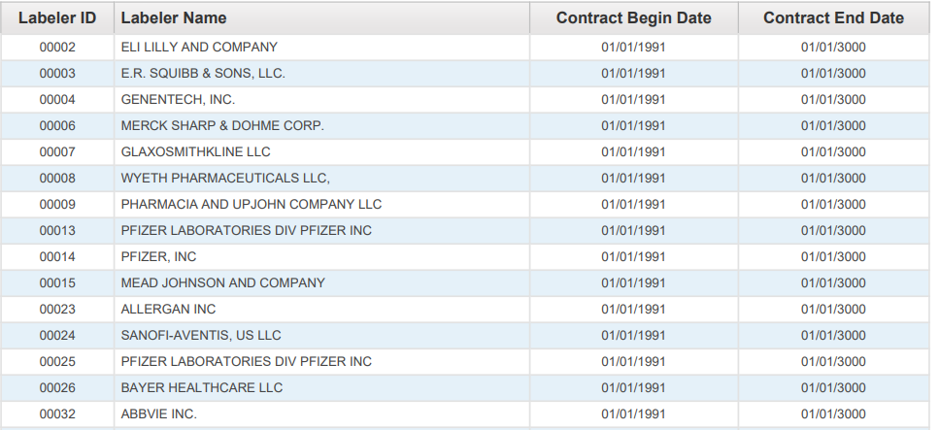

For a claim with drug HCPCS/CPT codes to be eligible for payment, the detail date of service must be prior to the NDC termination date. The NDC termination date represents the shelf-life expiration date of the last batch produced, as supplied on the Centers for Medicare and Medicaid Services (CMS) quarterly update. The date is supplied to CMS by the drug manufacturer/distributor.

Arkansas Medicaid will deny claim details with drug HCPCS/CPT codes with a detail date of service equal to or greater than the NDC termination date.

When completing a Medicaid claim for administering a drug, indicate the HIPAA standard 11-digit NDC with no dashes or spaces. The 11-digit NDC is comprised of three (3) segments or codes: a 5-digit labeler code, a 4-digit product code and a 2-digit package code. The 10-digit NDC assigned by the FDA printed on the drug package must be changed to the 11-digit format by inserting a leading zero (0) in one (1) of the three (3) segments. Below are examples of the FDA assigned NDC on a package changed to the appropriate 11-digit HIPAA standard format. Diagram 2 displays the labeler code as five (5) digits with leading zeros; the product code as four (4) digits with leading zeros; the package code as two (2) digits without leading zeros, using the “5-4-2” format.

*Diagram 2*

|  |  |  |
| --- | --- | --- |
| 00123 | 0456 | 78 |
| LABELER CODE  (5 digits) | PRODUCT CODE  (4 digits) | PACKAGE CODE  (2 digits) |

NDCs submitted in any configuration other than the 11-digit format will be rejected/denied. NDCs billed to Medicaid for payment must use the 11-digit format without dashes or spaces between the numbers.

See Diagram 3 for sample NDCs as they might appear on drug packaging and the corresponding format which should be used for billing Arkansas Medicaid.

*Diagram 3*

|  |  |
| --- | --- |
| 10-digit FDA NDC on PACKAGE | Required 11-digit NDC  (5-4-2) Billing Format |
| 12345 6789 1 | 12345678901 |
| 1111-2222-33 | 01111222233 |
| 01111 456 71 | 01111045671 |

B. Drug Procedure Code (HCPCS/CPT) to NDC Relationship and Billing Principles

HCPCS/CPT codes and any modifiers will continue to be billed per the policy for each procedure code. However, the NDC and NDC quantity of the administered drug is now also required for correct billing of drug HCPCS/CPT codes. To maintain the integrity of the drug rebate program, it is important that the specific NDC from the package used at the time of the procedure be recorded for billing. HCPCS/CPT codes submitted using invalid NDCs or NDCs that were unavailable on the date of service will be rejected/denied. We encourage you to enlist the cooperation of all staff members involved in drug administration to assure collection or notation of the NDC from the actual package used. It is not recommended that billing of NDCs be based on a reference list, as NDCs vary from one (1) labeler to another, from one (1) package size to another, and from one (1) time period to another.

Exception: There is no requirement for an NDC when billing for vaccines.

**I. Claims Filing**

The HCPCS/CPT codes billing units and the NDC quantity do not always have a one-to-one relationship.

Example 1: The HCPCS/CPT code may specify up to 75 mg of the drug whereas the NDC quantity is typically billed in units, milliliters or grams. If the patient is provided 2 oral tablets, one at 25 mg and one at 50 mg, the HCPCS/CPT code unit would be 1 (1 total of 75 mg) in the example whereas the NDC quantity would be 1 each (1 unit of the 25 mg tablet and 1 unit of the 50 mg tablet). See Diagram 4.

*Diagram 4*

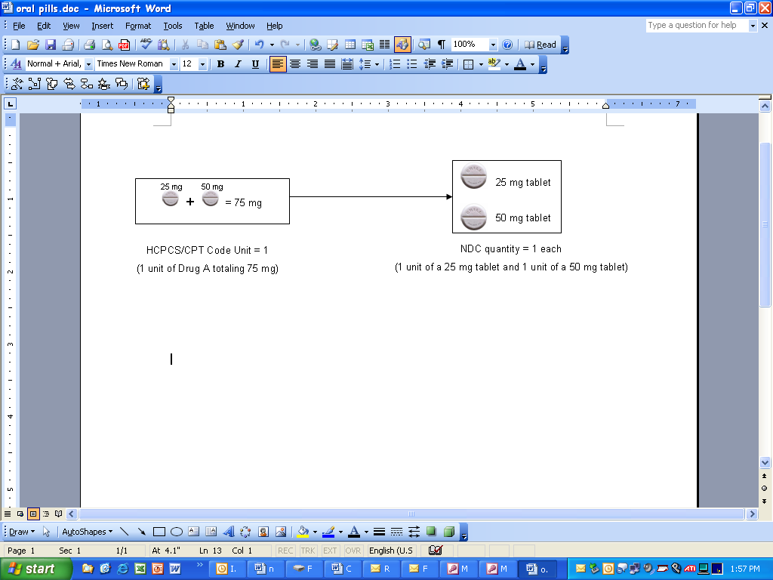

Example 2: If the drug in the example is an injection of 5 ml (or cc) of a product that was 50 mg per 10 ml of a 10 ml single-use vial, the HCPCS/CPT code unit would be 1 (1 unit of 25 mg) whereas the NDC quantity would be 5 (5 ml). In this example, 5 ml or 25 mg would be documented as wasted. See Diagram 5. For billing wastage, see bullets A (Electronic Claims Filing) and B (Paper Claims Filing) below.

*Diagram 5*

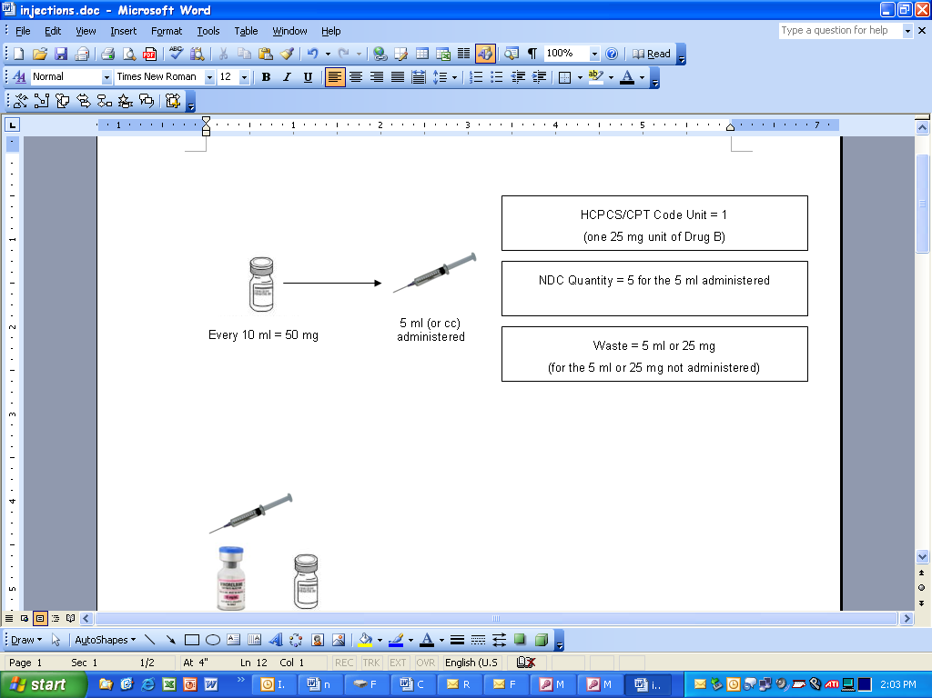

A. Electronic Claims Filing – 837P (Professional)

Providers are instructed to bill as follows:

* 1 NDC for a procedure – 1st/only detail shall be billed with no modifier
* 2 NDCs for same procedure – 1st detail shall be billed with a KP and 2nd gets billed with a KQ modifier
* 3 NDCs for same procedure – 1st detail shall be billed with a KP and 2nd & 3rd detail get billed with a KQ modifier
* 4 or more NDCs for same procedure – submit via paper claim
* Wastage of each NDC shall be billed on a separate line with a JW modifier.

NOTE: The NDCs listed above are not the same (unless with a JW modifier). Same NDCs shall be billed on a single line with appropriate units.

**NOTE: CMS definitions of modifiers:**

* KP = First drug of a multiple drug unit dose formulation
* KQ = Second or subsequent drug of a multiple drug unit dose formulation
* JW = Drug wastage

B. Paper Claims Filing – CMS-1500

Arkansas Medicaid will require providers billing drug HCPCS/CPT codes including covered unlisted drug procedure codes to use the required NDC format.

See Diagram 6 for CMS-1500.

**CMS-1500**

For professional claims, CMS-1500, list the qualifier of “N4”, the 11-digit NDC, the unit of measure qualifier (F2 – International Unit; GR – Gram; ML - Milliliter; UN – Unit), and the number of units of the actual NDC administered in the shaded area above detail field 24A, spaced and arranged exactly as in Diagram 6.

Providers are instructed to bill as follows:

* 1 NDC for a procedure – 1st/only detail shall be billed with no modifier
* 2 NDCs for same procedure – 1st detail shall be billed with a KP and 2nd gets billed with a KQ modifier
* 3 NDCs for same procedure – 1st detail shall be billed with a KP and 2nd & 3rd detail get billed with a KQ modifier
* 4 or more NDCs for same procedure – 1st detail shall be billed with a KP and 2nd and subsequent details shall be billed with a KQ modifier
* Wastage of each NDC shall be billed on a separate line with a JW modifier.

**NOTE: CMS definitions of modifiers:**

* KP = First drug of a multiple drug unit dose formulation
* KQ = Second or subsequent drug of a multiple drug unit dose formulation
* JW = Drug wastage

*Diagram 6*

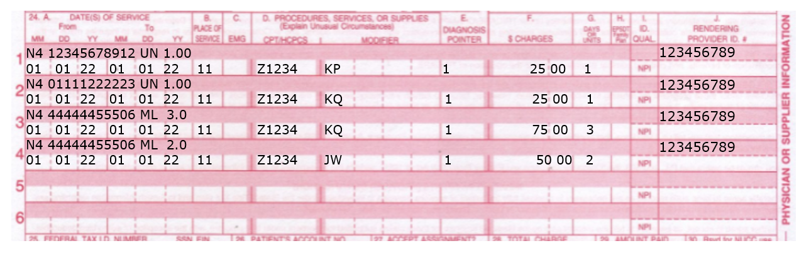

**II. Adjustments**

Paper adjustments for paid claims filed with NDC numbers will not be accepted. Any original claim will have to be voided and a replacement claim will need to be filed. Providers have the option of adjusting a paper or electronic claim electronically.

**III. Record Retention**

Each provider must retain all records for five (5) years from the date of service or until all audit questions, dispute or review issues, appeal hearings, investigations or administrative/judicial litigation to which the records may relate are concluded, whichever period is longer.

At times, a manufacturer may question the invoiced amount, which results in a drug rebate dispute. If this occurs, you may be contacted requesting a copy of your office records to include documentation pertaining to the billed HCPCS/CPT code. Requested records may include NDC invoices showing purchase of drugs and documentation showing what drug (name, strength and amount) was administered and on what date, to the beneficiary in question.

See Section 252.100 for additional information regarding drug code billing.

|  |  |
| --- | --- |
| 252.200 National Place of Service | 7-1-07 |

Below are listed the place of service or (POS) codes for Ambulance Transportation Services procedures.

Electronic and paper claims now require the same national place of service codes.

| Place of Service | POS Codes |
| --- | --- |
| Ambulance | 41 |
| Air Ambulance | 42 |

|  |  |
| --- | --- |
| 252.300 Ambulance Transportation Billing Instructions—Paper Only | 11-1-17 |

Bill Medicaid for professional services with form CMS-1500. The numbered items in the following instructions correspond to the numbered fields on the claim form. [View a sample form CMS-1500.](https://humanservices.arkansas.gov/wp-content/uploads/SampleCMS-1500.pdf)

Carefully follow these instructions to help the Arkansas Medicaid fiscal agent efficiently process claims. Accuracy, completeness, and clarity are essential. Claims cannot be processed if necessary information is omitted.

Forward completed claim forms to the Claims Department. [View or print the Claims Department contact information](https://humanservices.arkansas.gov/wp-content/uploads/Claims.docx).

NOTE: A provider delivering services without verifying beneficiary eligibility for each date of service does so at the risk of not being reimbursed for the services.

|  |  |
| --- | --- |
| 252.310 Completion of CMS-1500 Claim Form | 9-1-14 |

| Field Name and Number | Instructions for Completion |
| --- | --- |
| 1. (type of coverage) | Not required. |
| 1a. INSURED’S I.D. NUMBER (For Program in Item 1) | Beneficiary’s or participant’s 10-digit Medicaid or ARKids First-A or ARKids First-B identification number. |
| 2. PATIENT’S NAME (Last Name, First Name, Middle Initial) | Beneficiary’s or participant’s last name and first name. |
| 3. PATIENT’S BIRTH DATE | Beneficiary’s or participant’s date of birth as given on the individual’s Medicaid or ARKids First-A or ARKids First-B identification card. Format: MM/DD/YY. |
| SEX | Check M for male or F for female. |
| 4. INSURED’S NAME (Last Name, First Name, Middle Initial) | Required if insurance affects this claim. Insured’s last name, first name, and middle initial. |
| 5. PATIENT’S ADDRESS (No., Street) | Optional. Beneficiary’s or participant’s completemailing address (street address or post office box). |
| CITY | Name of the city in which the beneficiary or participant resides. |
| STATE | Two-letter postal code for the state in which the beneficiary or participant resides. |
| ZIP CODE | Five-digit zip code; nine digits for post office box. |
| TELEPHONE (Include Area Code) | The beneficiary’s or participant’s telephone number or the number of a reliable message/contact/ emergency telephone. |
| 6. PATIENT RELATIONSHIP TO INSURED | If insurance affects this claim, check the box indicating the patient’s relationship to the insured. |
| 7. INSURED’S ADDRESS (No., Street) | Required if insured’s address is different from the patient’s address. |
| CITY |  |
| STATE |  |
| ZIP CODE |  |
| TELEPHONE (Include Area Code) |  |
| 8. RESERVED | Reserved for NUCC use. |
| 9. OTHER INSURED’S NAME (Last name, First Name, Middle Initial) | If patient has other insurance coverage as indicated in Field 11d, the other insured’s last name, first name, and middle initial. |
| a. OTHER INSURED’S POLICY OR GROUP NUMBER | Policy and/or group number of the insured individual. |
| b. RESERVED | Reserved for NUCC use. |
| SEX | Not required. |
| c. RESERVED | Reserved for NUCC use. |
| d. INSURANCE PLAN NAME OR PROGRAM NAME | Name of the insurance company. |
| 10. IS PATIENT’S CONDITION RELATED TO: |  |
| a. EMPLOYMENT? (Current or Previous) | Check YES or NO. |
| b. AUTO ACCIDENT? | Required when an auto accident is related to the services. Check YES or NO. |
| PLACE (State) | If 10b is YES, the two-letter postal abbreviation for the state in which the automobile accident took place. |
| c. OTHER ACCIDENT? | Required when an accident other than automobile is related to the services. Check YES or NO. |
| d. CLAIM CODES | The “Claim Codes” identify additional information about the beneficiary’s condition or the claim. When applicable, use the Claim Code to report appropriate claim codes as designated by the NUCC. When required to provide the subset of Condition Codes, enter the condition code in this field. The subset of approved Condition Codes is found at [www.nucc.org](http://www.nucc.org/) under Code Sets. |
| 11. INSURED’S POLICY GROUP OR FECA NUMBER | Not required when Medicaid is the only payer. |
| a. INSURED’S DATE OF BIRTH | Not required. |
| SEX | Not required. |
| b. OTHER CLAIM ID NUMBER | Not required. |
| c. INSURANCE PLAN NAME OR PROGRAM NAME | Not required. |
| d. IS THERE ANOTHER HEALTH BENEFIT PLAN? | When private or other insurance may or will cover any of the services, check YES and complete items 9, 9a and 9d. Only one box can be marked. |
| 12. PATIENT’S OR AUTHORIZED PERSON’S SIGNATURE | Enter “Signature on File,” “SOF” or legal signature. |
| 13. INSURED’S OR AUTHORIZED PERSON’S SIGNATURE | Enter “Signature on File,” “SOF” or legal signature. |
| 14. DATE OF CURRENT:  ILLNESS (First symptom) OR INJURY (Accident) OR PREGNANCY (LMP) | Required when services furnished are related to an accident, whether the accident is recent or in the past. Date of the accident.  Enter the qualifier to the right of the vertical dotted line. Use Qualifier 431 Onset of Current Symptoms or Illness; 484 Last Menstrual Period. |
| 15. OTHER DATE | Enter another date related to the beneficiary’s condition or treatment. Enter the qualifier between the left-hand set of vertical, dotted lines.  The “Other Date” identifies additional information about the beneficiary’s condition or treatment. Use qualifiers:  454 Initial Treatment  304 Latest Visit or Consultation  453 Acute Manifestation of a Chronic Condition  439 Accident  455 Last X-Ray  471 Prescription  090 Report Start (Assumed Care Date)  091 Report End (Relinquished Care Date)  444 First Visit or Consultation |
| 16. DATES PATIENT UNABLE TO WORK IN CURRENT OCCUPATION | Not required. |
| 17. NAME OF REFERRING PROVIDER OR OTHER SOURCE | Primary Care Physician (PCP) referral is not required for DDTCS services. |
| 17a. (blank) | Not required. |
| 17b. NPI | Enter NPI of the referring physician. |
| 18. HOSPITALIZATION DATES RELATED TO CURRENT SERVICES | When the serving/billing provider’s services charged on this claim are related to a beneficiary’s or participant’s inpatient hospitalization, enter the individual’s admission and discharge dates. Format: MM/DD/YY. |
| 19. ADDITIONAL CLAIM INFORMATION | Identifies additional information about the beneficiary’s condition or the claim. Enter the appropriate qualifiers describing the identifier. See [www.nucc.org](http://www.nucc.org/) for qualifiers. | |
| 20. OUTSIDE LAB? | Not used for DDTCS Transportation Services. |
| $ CHARGES | Not required. |
| 21. DIAGNOSIS OR NATURE OF ILLNESS OR INJURY | Enter the applicable ICD indicator to identify which version of ICD codes is being reported.  Use “9” for ICD-9-CM.  Use “0” for ICD-10-CM.  Enter the indicator between the vertical, dotted lines in the upper right-hand portion of the field.  Diagnosis code for the primary medical condition for which services are being billed. Use the appropriate International Classification of Diseases (ICD). List no more than 12 ICD-9-CM or ICD-10-CM diagnosis codes. Relate lines A-L to the lines of service in 24E by the letter of the line. Use the highest level of specificity. |
| 22. RESUBMISSION CODE | Reserved for future use. |
| ORIGINAL REF. NO. | Any data or other information listed in this field does not/will not adjust, void or otherwise modify any previous payment or denial of a claim. Claim payment adjustments, voids, and refunds must follow previously established processes in policy. |
| 23. PRIOR AUTHORIZATION NUMBER | The prior authorization or benefit extension control number if applicable. |
| 24A. DATE(S) OF SERVICE | The “from” and “to” dates of service for each billed service. Format: MM/DD/YY.  1. On a single claim detail (one charge on one line), bill only for services provided within a single calendar month.  2. Providers may bill on the same claim detail for two or more sequential dates of service within the same calendar month when the provider furnished equal amounts of the service on each day of the date sequence. |
| B. PLACE OF SERVICE | Two-digit national standard place of service code. See Section 292.200 for codes. |
| C. EMG | Enter “Y” for “Yes” or leave blank if “No.” |
| D. PROCEDURES, SERVICES, OR SUPPLIES |  |
| CPT/HCPCS | One CPT or HCPCS procedure code for each detail. |
| MODIFIER | Not applicable to DDTCS Transportation claims. |
| E. DIAGNOSIS POINTER | Enter the diagnosis code reference letter (pointer) as shown in Item Number 21 to relate to the date of service and the procedures performed to the primary diagnosis. When multiple services are performed, the primary reference letter for each service should be listed first; other applicable services should follow. The reference letter(s) should be A-L or multiple letters as applicable. The “Diagnosis Pointer” is the line letter from Item Number 21 that relates to the reason the service(s) was performed. |
| F. $ CHARGES | The full charge for the service(s) totaled in the detail. This charge must be the usual charge to any client, patient, or other beneficiary of the provider’s services. |
| G. DAYS OR UNITS | The units (in whole numbers) of service(s) provided during the period indicated in Field 24A of the detail. |
| H. EPSDT/Family Plan | Not applicable to DDTCS Transportation Services. |
| I. ID QUAL | Not required. |
| J. RENDERING PROVIDER ID # | Enter the 9-digit Arkansas Medicaid provider ID number of the individual who furnished the services billed for in the detail or |
| NPI | Enter NPI of the individual who furnished the services billed for in the detail. |
| 25. FEDERAL TAX I.D. NUMBER | Not required. This information is carried in the provider’s Medicaid file. If it changes, please contact Provider Enrollment. |
| 26. PATIENT’S ACCOUNT N O. | Optional entry that may be used for accounting purposes; use up to 16 numeric or alphabetic characters. This number appears on the Remittance Advice as “MRN.” |
| 27. ACCEPT ASSIGNMENT? | Not required. Assignment is automatically accepted by the provider when billing Medicaid. |
| 28. TOTAL CHARGE | Total of Column 24F—the sum all charges on the claim. |
| 29. AMOUNT PAID | Enter the total payments previously received on this claim Do not include amounts previously paid by Medicaid. Do not include in this total the automatically deducted Medicaid or Arkids-B co-payments. |
| 30. RESERVED | Reserved for NUCC use. |
| 31. SIGNATURE OF PHYSICIAN OR SUPPLIER INCLUDING DEGREES OR CREDENTIALS | The provider or designated authorized individual must sign and date the claim certifying that the services were personally rendered by the provider or under the provider’s direction. “Provider’s signature” is defined as the provider’s actual signature, a rubber stamp of the provider’s signature, an automated signature, a typewritten signature, or the signature of an individual authorized by the provider rendering the service. The name of a clinic or group is not acceptable. |
| 32. SERVICE FACILITY LOCATION INFORMATION | If other than home or office, enter the name and street, city, state, and zip code of the facility where services were performed. |
| a. (blank) | Not required. |
| b. (blank) | Not required. |
| 33. BILLING PROVIDER INFO & PH # | Billing provider’s name and complete address. Telephone number is requested but not required. |
| a. (blank) | Enter NPI of the billing provider or |
| b. (blank) | Enter the 9-digit Arkansas Medicaid provider ID number of the billing provider. |

|  |  |
| --- | --- |
| 252.400 Special Billing Procedures |  |
| 252.410 Levels of Ambulance Life Support (ALS) and Basic Life Support (BLS) | 8-3-20 |

Levels of ambulance life support are not applicable to transports by air ambulance and apply to ground ambulance transportation only. Ambulance transportation providers who bill advanced life support (ALS) services must be licensed as advanced emergency medical technicians (EMTs) or paramedics. All ambulance transports must be made and billed to Medicaid appropriately according to the licensure level of the provider. The level of services billed to Medicaid must be in compliance with the level of care provided and reflected by the license of the provider.

Basic Life Support (BLS) services are supportive and non-definitive in nature. BLS assessment includes brief and limited patient assessment and management procedures including evaluation of vital signs, mental and neurologic states, and hemodynamic stability.

To bill at the ALS level of service, the transportation event must include provision of an ALS assessment or at least one (1) ALS intervention. An ALS assessment is performed by an advanced EMT or paramedic as part of an emergency response that is necessary because the beneficiary’s reported condition at the time of the service indicates only an advanced EMT or paramedic is qualified to perform the assessment. In the case of an appropriately dispatched ALS emergency service and if the ALS crew appropriately completes an ALS assessment, the services provided by the provider during that transportation event are covered at the ALS level of service.

|  |  |
| --- | --- |
| 252.420 Medical Necessity Requirement | 10-13-03 |

All Medicaid transportation services provided must be medically necessary and any payments made for services that are found not to be medically necessary will be subject to recoupment. It is the responsibility of the transportation provider to maintain documentation that will verify the medical necessity of transportation rendered.