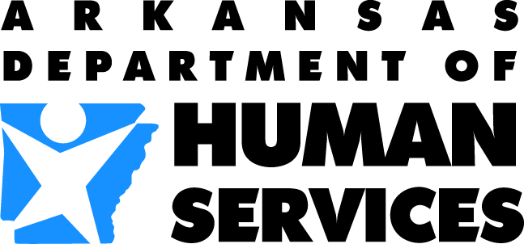 | Division of Medical Services  Office of Long Term Care | 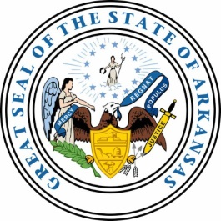
http://humanservices.arkansas.gov/dms/Pages/oltcHome.aspx
PO Box 8059, Slot S409, Little Rock, AR 72203-8059
501-682-8430 · Fax: 501-682-1197
RECIPROCITY LICENSING QUESTIONNAIRE

TO THE STATE OF
The following Licensed Nursing Home Administrator has made application for reciprocity as a NHA in the State of Arkansas. According to the information the applicant has filed, the applicant is
currently licensed in your state. Please complete the following form, sign and return to our office in the self-addressed envelope within ten (10) days.

NAME AND ADDRESS:

_______________________________________ Social Security #: __________
_______________________________________
_______________________________________ Date of Birth: ______________

LICENSE

License Number ______ State * __________ Date Issued ________ Date Expires ________

*If this is not the state of original license, was license through reciprocity/endorsement?
_____ Yes _____ No From what state? __________________________________

Status of License: Active _______ Inactive _______ Expired _______

Exam: NAB _____ PES _____ Other _____ Date ________ State _____________________

Score: Raw _____ Scale _____ Date of Exam ____________ State ____________________

Was an AIT/Practicum successfully completed? Yes _____ No _____

If yes, length of AIT/Practicum: ____________________________________________________

Has the applicant ever been disciplined by the Board? Yes _____ No _____

If yes, please explain: __________________________________________________________

____________________________________________________________________________

Is there any investigation or disciplinary action pending? Yes _______ No _______

CERTIFICATION: NHA by the ACHCA: Yes _____ No _____

___________________________________________________________
State Authorized Signature Title
S E A L
___________________________________________________________
Phone Number City/State

Apps 6
humanservices.arkansas.gov
Protecting the vulnerable, fostering independence and promoting better health

